**Activity**

1. **Paragraphs, Line Breaks and Preformatting**

In this Activity you will use the <P> and <BR> tags to create line breaks in text.We will also demonstrate the use of <pre>.

1. Load Notepad and begin a new HTML document.

2. Enter the usual structural HTML tags. Set the title to "Formatting text".

3. Within the body type in the following text exactly as it appears below. Not how ‘This is cool’ has

been typed. Do not use any HTML tags to format it at this stage.

Users of HTML are sometimes surprised to find that HTML gives them little control over the way

that a page is displayed. It should be remembered that HTML was developed as a means of marking

up the structure of a document not as a way of determining its presentation. Formatting text to appear

on a Web page is therefore different from formatting text to appear in a printed document.

This

is

Cool.

4. Save the document as **format.html** in your myapps folder and load it in your browser to view it. Note

that ‘This is cool’ is displayed without the line breaks.

5. Resize your browser and watch how the text is reformatted to fit in the resized browser window.

6. Return to Notepad and make the changes as shown in Figure 1.

7. Save the file again and load it in your browser to check your HTML. Resize the browser and watch

how the document is reformatted for the resized window?

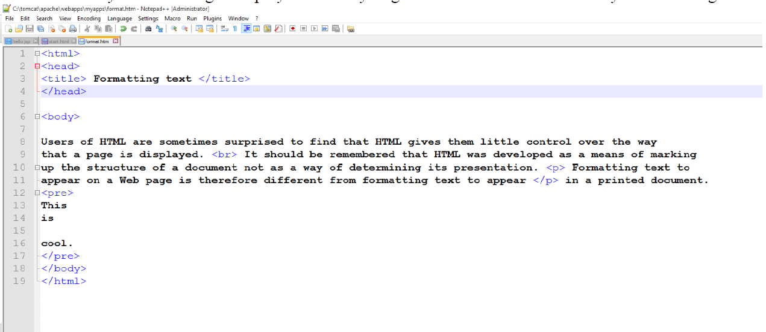

1. **Headings**

In this Activity you will set up a page heading and sub-heading for the Web page begun in Activity 5 and use the HTML headings tags to implement it.

1. Load format.htm in MS-Notepad.

2. Within the <head> tags, add <meta charset="UTF-8">. It does not matter whether it is below

or after the <title> tag.

3. Set up the page heading "Formatting text" and place the <H1> heading tags around it, in other words,

<H1>Formatting text</H1>.

4. Reload format.html in your browser. You will notice that the effect of the <H1> tag is to display the

text not only in an enlarged font size but also to include extra space above and below it. So you do

not need a <BR> or <P> tag as well.

5. Return to Notepad and use the <H2> tag to create a sub-heading for the page, "Paragraphs and line

breaks".

6. Add <hr> between ‘This’ and ‘is’.

7. Reload the document in your browser to check the HTML and you should have an output like in

Figure 2.

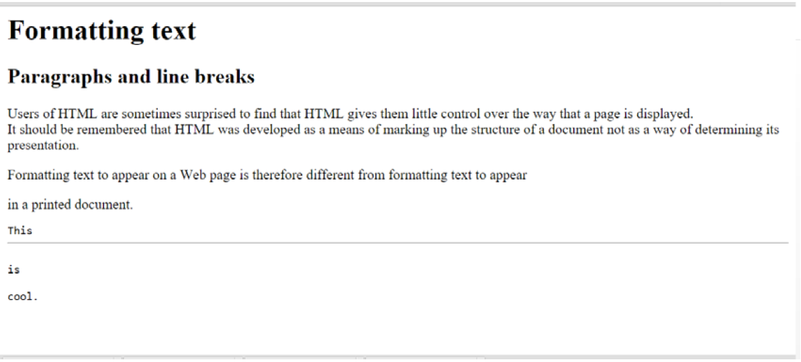

1. **Lists**

In this Activity you will create a series of lists to practise your HTML list-building skills.

1. Load format.html in Notepad.

2. Underneath the text, create three lists as follows:

a. List one should be a circled bulleted (i.e. unordered) list, using square bullets, giving the

days of the week.

b. List two should be a numbered list of the months of the year. Make the numbers lowercase

roman numerals.

c. List three should be a definition list of the four Courses.

3. Save the file and view it in your Web browser to ensure that it displays as desired.

4. Reload format.html in Notepad and create a new bulleted list showing the four seasons. Within each

season create a numbered sub list of the appropriate Branches of the course.

5. Save the file and load it in your Web browser to examine the document.

1. **Comments**

In this Activity you will use preformatted text and HTML comments.

1. Load format.html in Notepad.

2. Place an HTML comment before the lists you created.

3. Save the file and load it in a Web browser.

1. **Linking to sections within a document**

This Activity sets up links to sections within the documents created by Activity 8

1. Open Notepad and load **index.htm**l.

2. Copy the following text twice into the body of the file above the hyperlinks in order to create a long

file. Rename section two to section three when copying it for the second time.

section two

<P>

Lorem ipsum dolor sit amet, consectetuer adipiscing elit, sed diam

nonummy nibh euismod tincidunt ut laoreet dolore magna aliquam

erat volutpat. Ut wisi enim ad minim veniam, quis nostrud exerci

tation ullamcorper suscipit lobortis nisl ut aliquip ex ea commodo

consequat..

<P>

Duis autem vel eum iriure dolor in hendrerit in vulputate velit esse

molestie consequat, vel illum dolore eu feugiat nulla facilisis at vero

eros et accumsan et iusto odio dignissim qui blandit praesent

luptatum zzril delenit augue duis dolore te feugait nulla facilisi.

<P>

3. Now define the location section two by amending the text in the following way.

<A NAME="section_two">section two</A>

4. Define the location section three in the same way. Save the file.

5. Save this file as filetwo.html, overwriting the previous file.

6. Re-open index.html and add the following hyperlinks to the top of the <body> section:

• Section Two

• Section Three

• File Two: Section Two

• File Two: Section Three

7. Ensure that the links work by reloading index.htm in your Web browser.

1. **Changing the appearance of links**

In this Activity you will set up a colour scheme for a Web page by using the BGCOLOR, TEXT, LINK, VLINK

and ALINK attributes of the BODY tag.

1. Open Notepad and load **index.html**. Create the following colour schemes for the page using either

hexadecimal values or colour names (see your textbooks):

a. white background, black text and red hyperlinks.

b. black background, white text and cyan hyperlinks.

c. your own colour scheme.

2. View the pages in the browser.

1. **Creating a Table**

The objective of this Activity is to create a timetable for CSC5003 students to be displayed on a Web page as

shown below:

TIME TABLE

